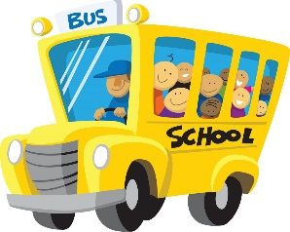

Welcome to a new school year!  Thank you for sharing your child with me this year.  The start of a new year holds the promise of new discovery and learning, as well as the prospect of personal growth in all areas.  I look forward to learning more about each child as we venture out this next year together.  My name is Sarah Coyle and I will be your child’s special education case manager.

I am excited to be working with your child and will do my best to make learning a rewarding experience.  We have a very busy and exciting year in store for us! I realize that teaching your child is a privilege, as well as a tremendous responsibility.  I will do my best this year to ensure that each student has a motivating and enriching learning experience.  However, I cannot do this alone: I need your help.  We both need to be partners in the learning process.  I need each of you to encourage your child at home by helping to ensure that they have completed their assignments and help them study, if necessary. More importantly, please read to/with them.

My goal for your child this year is to develop healthy study habits that they will be able to carry throughout elementary school and beyond.  I look forward to working with you and your child.  I know with your help we are going to have great year!

I am looking forward to working as a team and making this a memorable and successful year for your child.

Sincerely,

Sarah Coyle

[scoyle@cbsd.org](mailto:scoyle@cbsd.org)